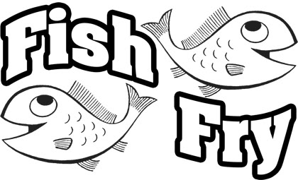 |  | 2026 FISH FRY  New Dundee Community Centre  Wed Sept 16, 2026  2 Seatings: 4:30 - 5:45 PM  6:00 - 7:15 PM
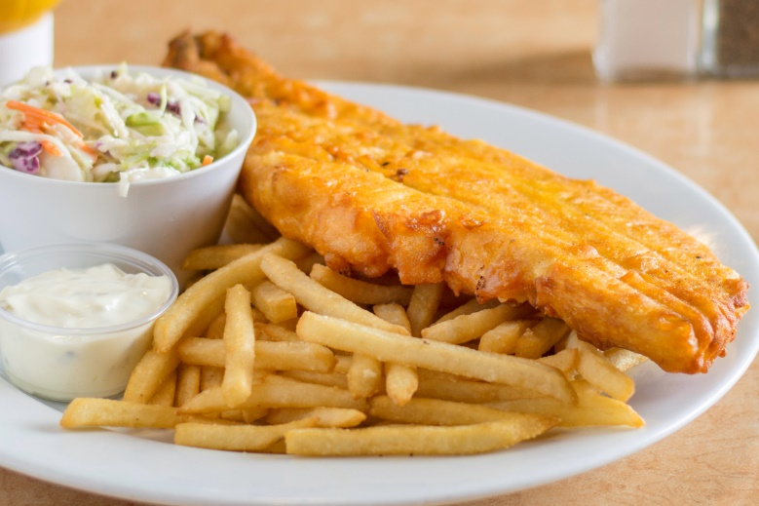 |  |  | Advanced Sales Only & Take Out Available
Adults (13 +) | $27
Take Out | $27 (1 pc. fish & chips, coleslaw only)
Children (5 to 12) | $15
*Prices include applicable taxes
Limited number of tickets available – advanced sales only
Cash or e-transfer to NewDundeebot@yahoo.com
“fishfry2026” for answer to security question
Fish & Chips with Salads, Drinks & Dessert |  |  | 
Proceeds Support New Dundee
Community Projects
- Remembrance Day Service on Nov 7
- Community Christmas Lights
- Community Beautification
- Community Events
Community Website (www.newdundee.ca)
 | Tickets available at: New Dundee Emporium – PCS Security
 | Information and Tickets (available Sept 1/26): Linda Darkes (226) 747-0003

